**CS 570 Software Testing**

# HOP01B – Java SDK in VSCode

1/31/2019 Developed by Sam Chung

School of Technology & Computing (STC)

City University of Seattle (CityU)

**Caution**

* If you already finished this module through any CityU Technology Institute (TI) courses,  
  just skim this module and skip it.
* Some version numbers may not match with the newly released ones.  
  If so, stay with the most recent ones.
* We target Windows OS. So, Mac may have different options.
* We cannot explain every steps. This cookbook always needs your own creative judgement.

**Learning Outcomes**

* Learn how to install the Java SE Development Kit (JDK) on your local development environment.

**Install Java SDK**

1. Visit Java SE 11.0.2 (LTS) downloads at <https://www.oracle.com/technetwork/java/javase/downloads/index.html>

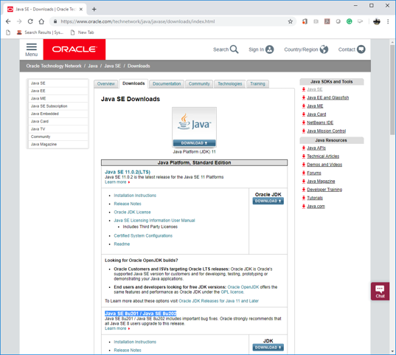

1. Press Oracle JDK Download based on your laptop.

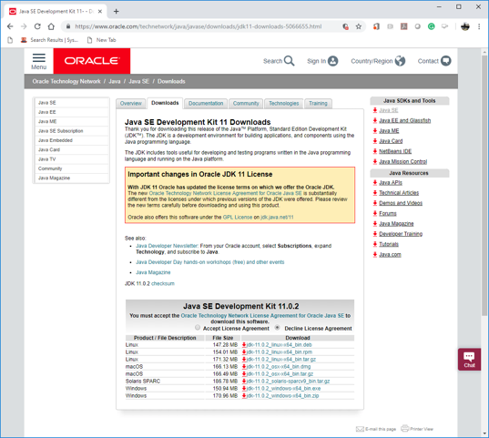

1. Accept the license agreement and download a correct Java SDK 11.0.2.  
   For my Windows Laptop, I chose “jdk-11.0.2_windows-x64_bin.exe”
2. Install the Java SDK.

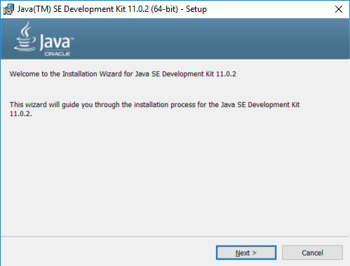

1. Visit the installed directory.  
   Remember the directory path.  
   For example, “C:\Program Files\Java\jdk-11.0.2”

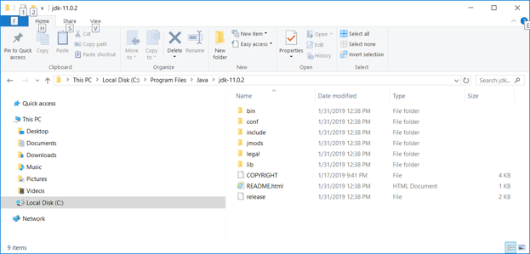

1. Set up the “JAVA_HOME” environment variable.  
   <https://docs.oracle.com/cd/E19182-01/820-7851/inst_cli_jdk_javahome_t/>   
   Assume that you use a Windows platform.
   1. Right click “Windows” icon  from your start menu bar.
   2. Select “System” menu item.
   3. On the Advanced tab, select Environment Variables.

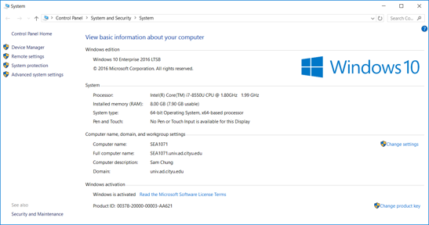

* 1. Select the “Advanced system settings” tab.

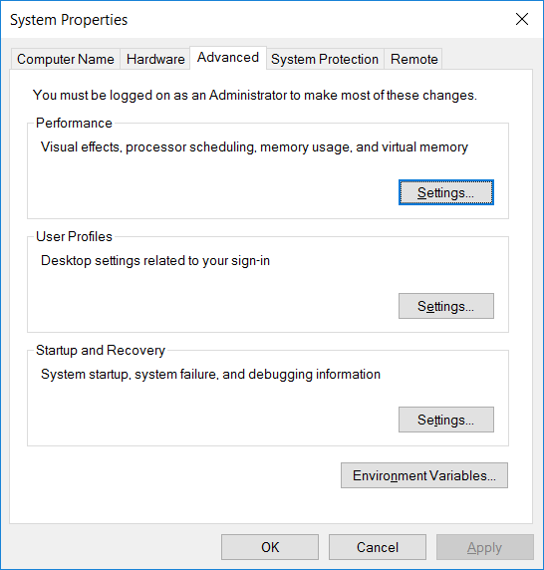

* 1. Select the “Environment Variable ….” Button.

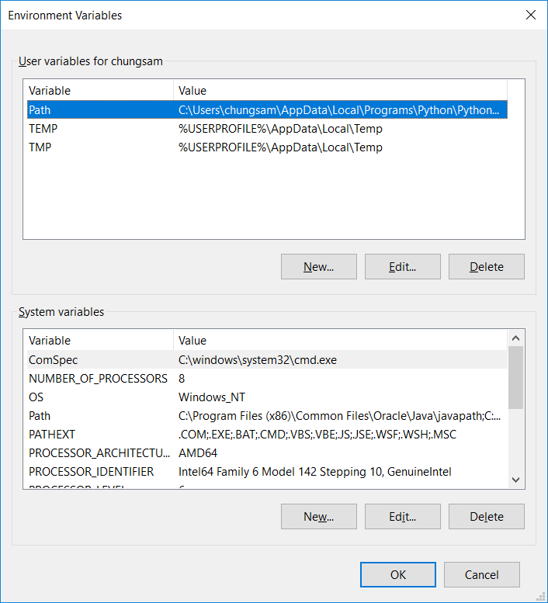

* 1. Add **a new system variable** “JAVA_HOME” to your system.  
     For example, select the “New…” of the “System variables”

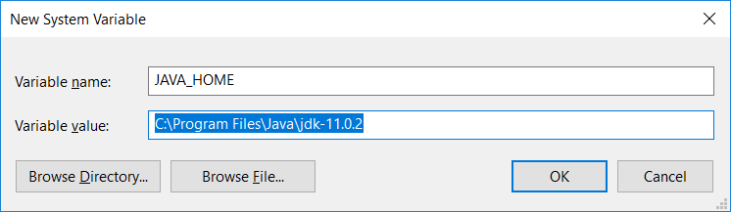

* 1. Edit the “Path” by using the “JAVA_HOME” environmental variable.

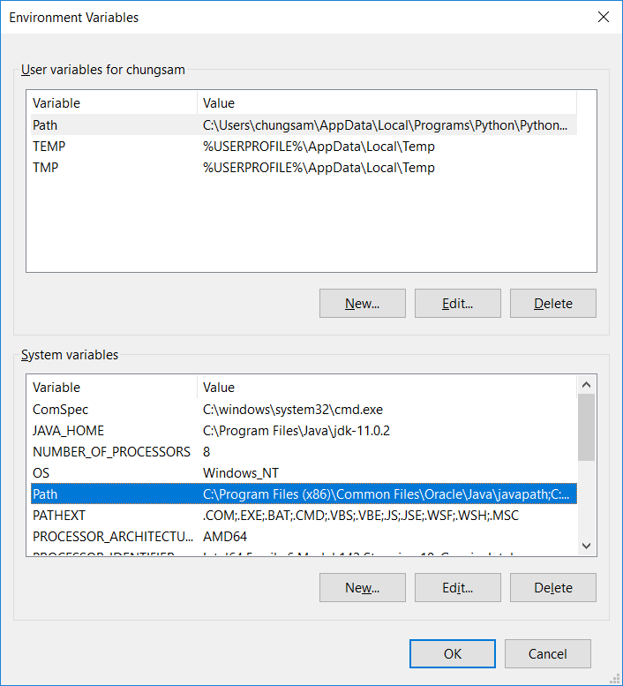

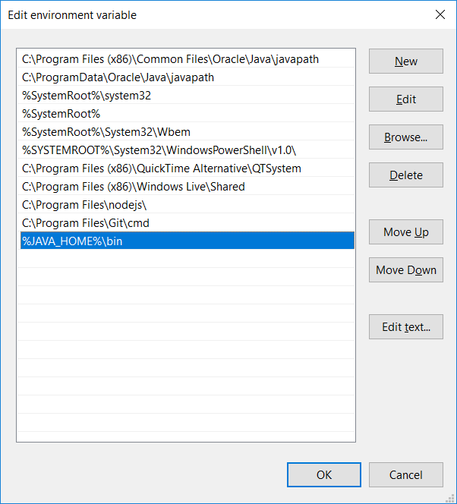

h) Add/Update the CLASSPATH to ensure Java finds and loads classes in Java programs as follows.

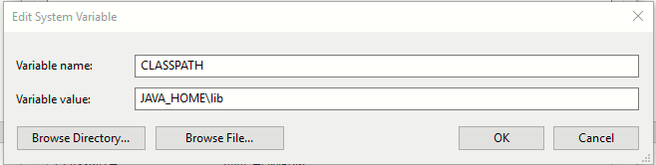

1. Test whether your Java SDK was correctly installed or not.
   1. Open your terminal (Windows: Windows + R, then “cmd”) (MacOS: Command + Spacebar, then “terminal”)
   2. Type “java -- version”

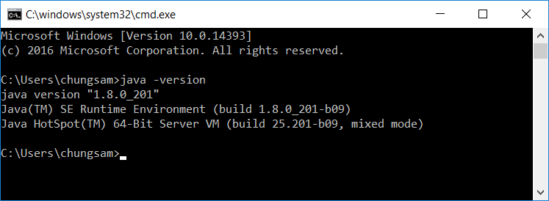

**Questions:**Answer each question.   
Show a good reference(s) to support your answer.

1. What does ‘Oracle LTS’ stand for?   
   For what purpose?

(Answer)

1. Why do we use the “JAVA_HOME” environment variable?   
   (Answer)
2. Why do we define the “Path”?  
    (Answer)
3. What is the difference between “PATH” and “CLASSPATH”?

(Answer)